Plan View

186 m

0 m

320 m

FBP X

FBP Y

FBP Z

FCS X

FCS Y

FCS Z

Fire line

Road

320 m

160 m

300 m

250 m

150 m

100 m

50 m

Time averaged velocity grid size 50 mm (50s to 379 s)

Canopy height=18 m

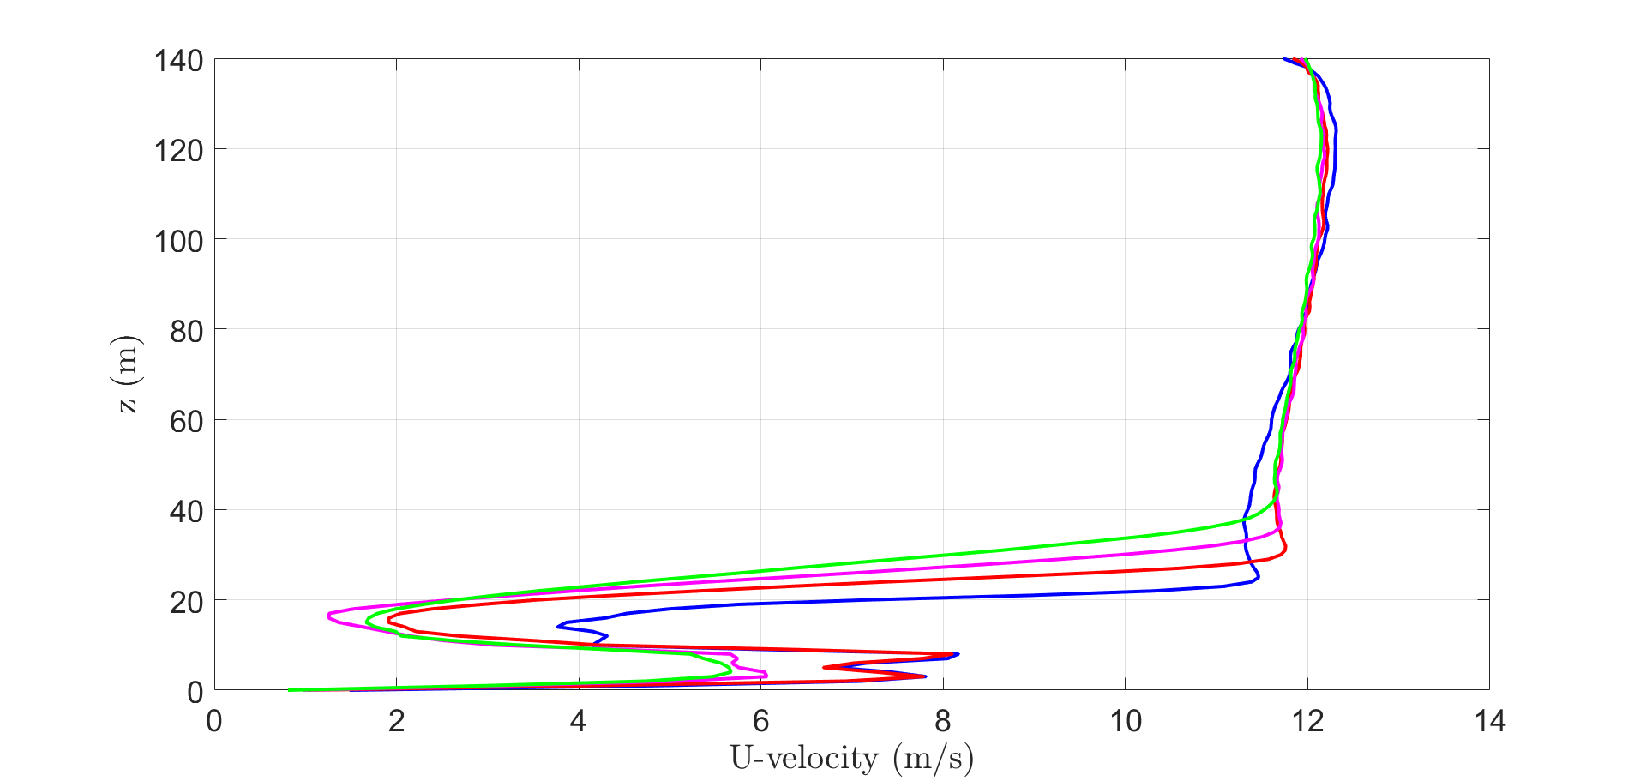

Time averaged velocity grid size 100 mm ( 45s to189 s)

Canopy height=18 m

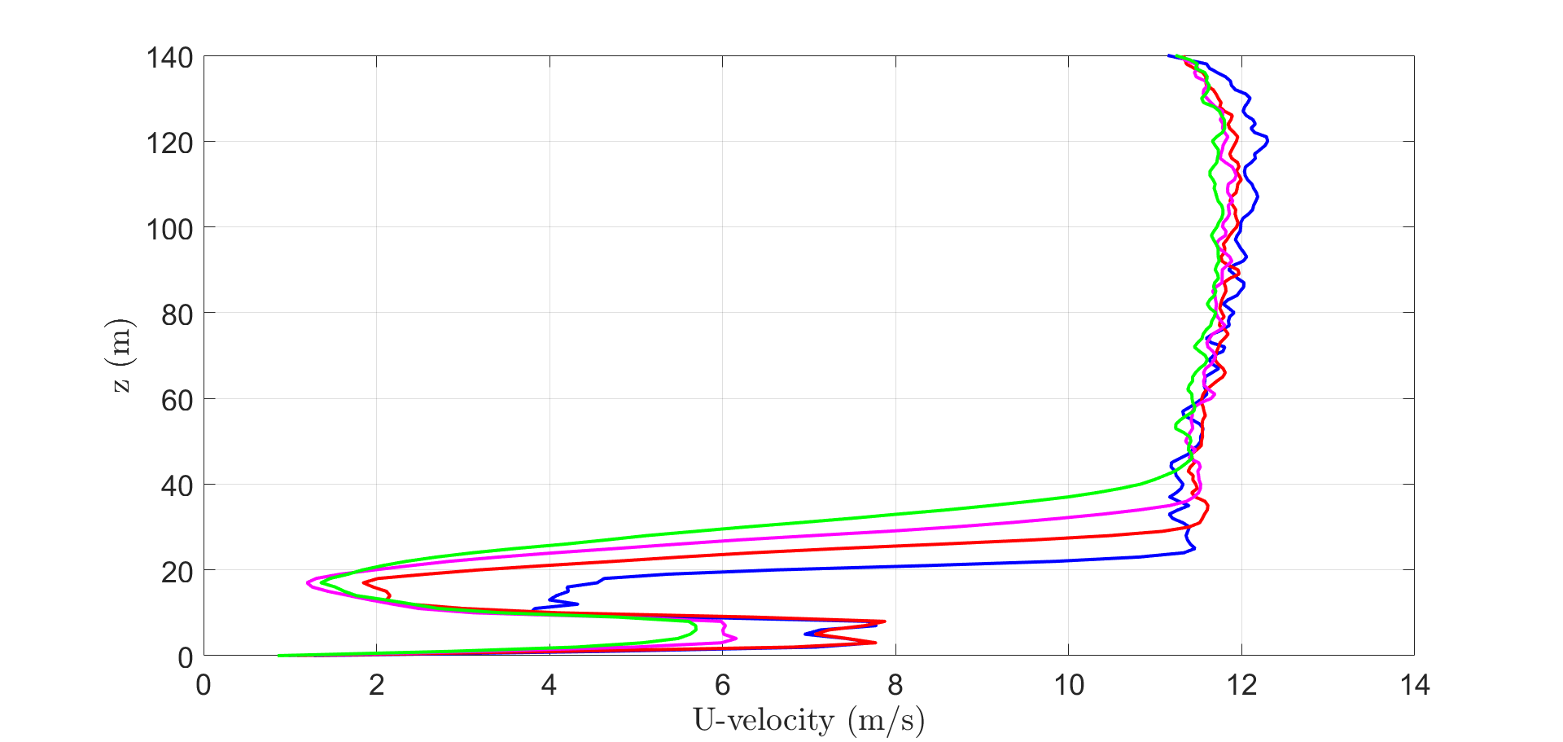

Time series velocity at 120 m height 50 mm grid

At x=50 m, 100 m, 150 m, 300 m

Time series velocity at 17 m height 50mm grid

At x=50 m, 100 m, 150 m, 300 m, and anemometer

|  |  |  |
| --- | --- | --- |
|  | Experiment | Simulation 5DTT (45 s t0 366 s) |
| Average wind velocity (m/s) | 1.4 $±$ 0.6 | 1.39 |

Wind profile (smv)

|  |
| --- |
| After 366 seconds |

Single tree burning

|  |  |  |
| --- | --- | --- |
|  | Number of firebrands collected | Total mass collected (g) |
|  | 70 | 18 $±$ 4 |
| Grid 50 mm with default drag model | 63 | 18.63 |
| Grid 50 mm with Haider drag model | 73 | 18.82 |

Firebrand number distribution

|  |
| --- |
| Default drag model |
| Haider drag model |